
HACK TO HIRE
Submitted by
MONISHA K(7376252AL173)
ABOUT THE PROGRAM
Event Title: HACK TO HIRE
The event aims to bridge the gap between real-world business challenges and innovative technological solutions. It is a platform where creativity meets purpose. The event empowers students to tackle real-world problems through technology-driven innovation. Participants will collaborate, ideate, and present practical solutions that can make a tangible impact on society and industry. It's not just about building prototypes — it's about engineering meaningful change. Through detailed research and analysis, they will propose cutting-edge tech-driven solutions that enhance efficiency, reduce costs, and streamline processes. This initiative not only fosters problem-solving skills but also sparks potential startup ideas, paving the way for impactful innovations in various industries.
S.NO | DESCRIPTION | DETAILS
1. | Name of the student | Monisha K
2. | Register Number | 7376252AL173
3. | Department | B.Tech.Artificial Intelligence and Machine Learning
4. | Year of study | 1
5. | Contact no | 9025996304
6. | Mail id | monishak.al25@bitsathy.ac.in
7. | Location | Bannari Amman Institute of Technology,Sathyamangalam,Erode
ABOUT THE STUDENT
PROBLEM UNDERSTADING REPORT
DOMAIN(Agriculture)
S0269. ENHANCING FARMER PRODUCTIVITY THROUGH INNOVATIVE TECHNOLOGY SOLUTIONS

- Problem Statement
In many parts of Tamil Nadu, farmers continue to practice the traditional method of agriculture. This practice result in low productivity in agriculture due to many issues. Especially the farmers in Coimbatore region faces a list of issues such as water scarcity, climatic changes, rising labour costs, and insufficient market support leading to low productivity.

- Aim
The main aim of this report is to approach the farmers in my locality with a professional mindset to identify the scope, stakeholders, requirements and local relevance of low agricultural productivity and to deeply understand the problem statement.

- Scope
Low agricultural productivity in the Coimbatore region is primarily driven by significant water scarcity, soil degradation, labour shortages, and market volatility. These issues are exacerbated by climate change and the fragmentation of landholdings, which limit the adoption of modern farming technology.

Factors contributing low productivity:
Water scarcity and poor management
- Coimbatore region receives less rainfall than many parts of Tamil Nadu, and agriculture is highly dependent on well and canal irrigation.
- Over-exploited groundwater resources and unreliable monsoons lead to water scarcity, especially in blocks with low rainfall, such as parts of Tirupur district, which affects Coimbatore's key crops like coconut.
- A 2024 study on coconut farming indicated that while water scarcity was less acute in Coimbatore district than in Tirupur, it remained a significant constraint in past years due to rainfall dependency.
- While Coimbatore region has rivers like the Noyyal and Bhavani, its agriculture is highly dependent on unpredictable monsoon rains. Erratic rainfall, coupled with frequent dry spells and droughts, directly impacts the region's water supply and reduces crop yields.

Soil degradation and nutritional deficiency
- The overuse of chemical fertilizers and pesticides and continuous cropping without proper management lead to decline in soil fertility.
- Some surveys had found that the Coimbatore region’s soil did not contain the essential nutrients such as Zinc, Copper, Magnesium and Iron etc.
- Certain soil series, like Peelamedu, have high alkalinity. Additionally, the use of heavy machinery can cause soil compaction, which reduces aeration and root growth.
- Decades of intensive cultivation have depleted the organic matter in the soil, diminishing its ability to retain water and nutrients. This makes fertilizer use inefficient and leads to groundwater contamination.

Labour shortages and high costs
- Shortages of agricultural labour, and the consequent high wages for skilled tasks like coconut harvesting are major challenges faced by farmers.
- The migration of rural youth to urban areas for non-farm employment opportunities is a major contributor to this labour deficiency.
- This scarcity and high cost of labour make manual operations, such as coconut harvesting challenging.

Mismanagement of crops
- Mismanagement of crops in agriculture can lead to soil degradation, reduced yields, and environmental harm.
- Use of chemical fertilizers and pesticides can degrade soil health, contaminate water sources and harm beneficial organisms.
- These practices often leads to diminishing returns in crop productivity and long-term ecological damage.
- Overwatering or poor drainage causes waterlogging, salinization and depletion of freshwater resources.
- Growing the same crop repeatedly on the same land decreases specific nutrients and increases vulnerability to pests and diseases.

Pest and disease
- Pests like the rugose spiralling whiteflies and diseases such as root wilt are persistent
problems, particularly for major crops like coconut.
- Outbreaks of new and exotic pests also threaten crop health and yield.

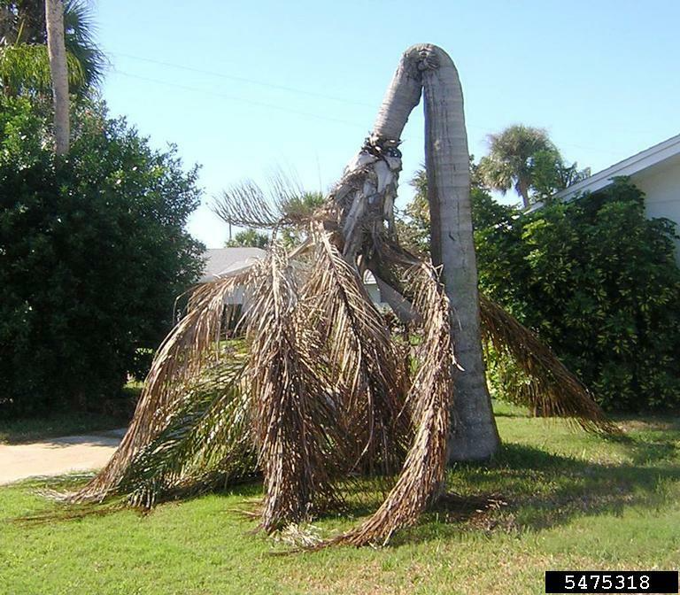
The above picture shows the trunk collapse of a coconut tree due to stem bleeding disease. It is a disease which destroys the coconut plantations in Coimbatore region.

The insect in the above picture is called as coconut leaf roller which is one of the major threat to farmers cultivating coconut trees.(pest)
Fragmented land holdings
- Population growth has led to the fragmentation of agricultural lands, making large-scale, mechanized farming difficult. This results in higher per-unit production costs for small and marginal farmers.

Market and financial constrains
- Price fluctuations and market volatility for agricultural products make it difficult for farmers to achieve stable and profitable incomes.
- Many small and marginal farmers face difficulties accessing affordable credit, which limits their ability to invest in improved farming technologies and inputs.
Climatic changes
- Changes in the timing and distribution of rainfall affect water availability for crops, even if total annual rainfall increases. This impacts sowing and harvesting schedules and increases water scarcity issues.
- The irregular temperature changes in Coimbatore region leads to lower yields for major crops like rice, maize and groundnut due to heat stress during critical growth stages.

- Local relevance
- Kangayam
- Kullampalayam
- Pudhupalayam
- Uthiyur
- Kaatupalayam
- Kaadaiyur
- Semmangalipalayam
Common issues reported:
- Water scarcity
- Labour deficiency
- High wages for workers
- Input cost is high
- Lack of capital to invest
- Sudden attack of unknown pest and diseases
- Does not have any educated people to guide

- Stakeholder
Local farmers

Name | Designation,place,date and time of visit | Contact
Mr. P. Lingasamy | Farmer, Pudhupalayam, | 9943851761
Mr. L. Kanagaraj | Farmer, Kangayam,19/10/2025,4.30pm | 9952675585
Mr.Velusamy | Farmer,kaatupalayam,19/10/2025,12.20am | 9688177028

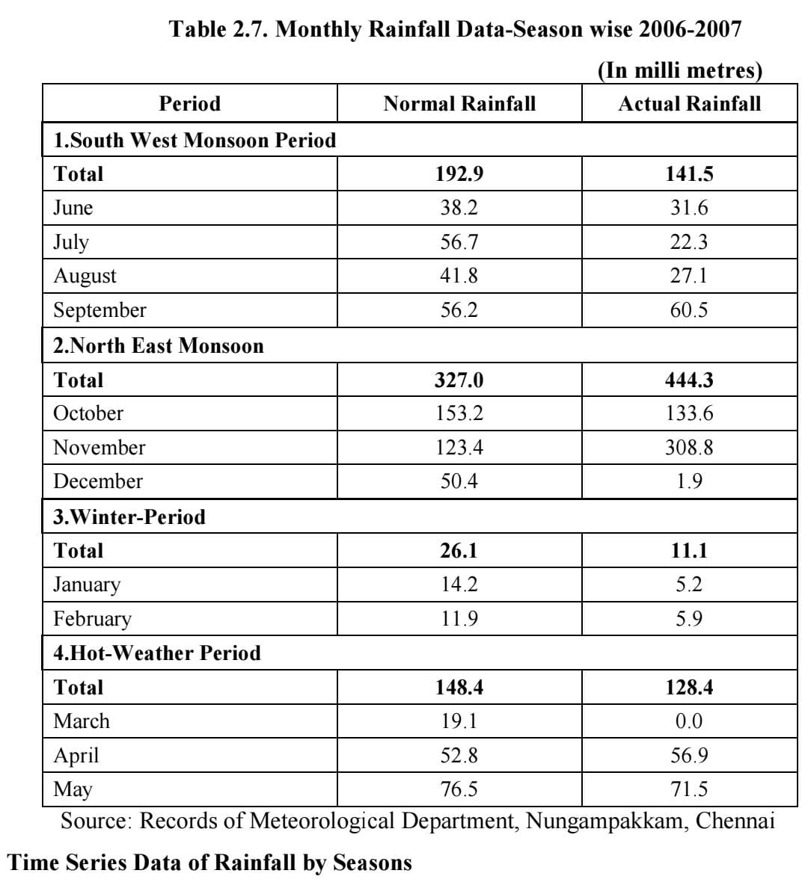

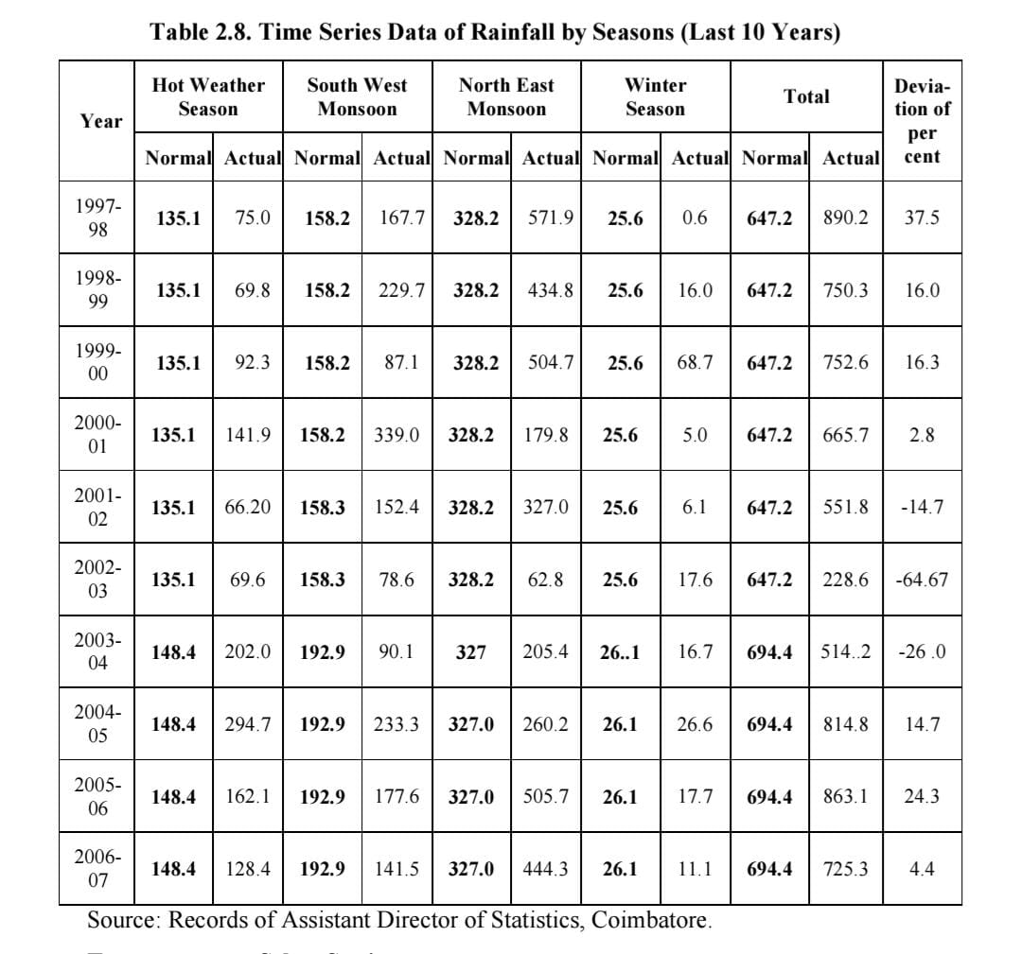
From the above tables ,The rainfall in Coimbatore region is not constant it varies from season to season and year to year. This shows that the rainfall pattern is changing, with more rain concentrated in the North East Monsoon and reduced rain during other periods.
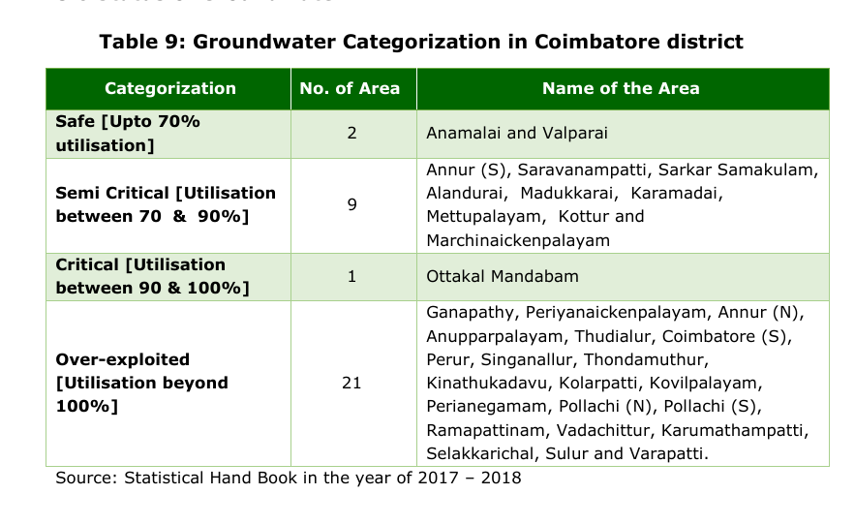
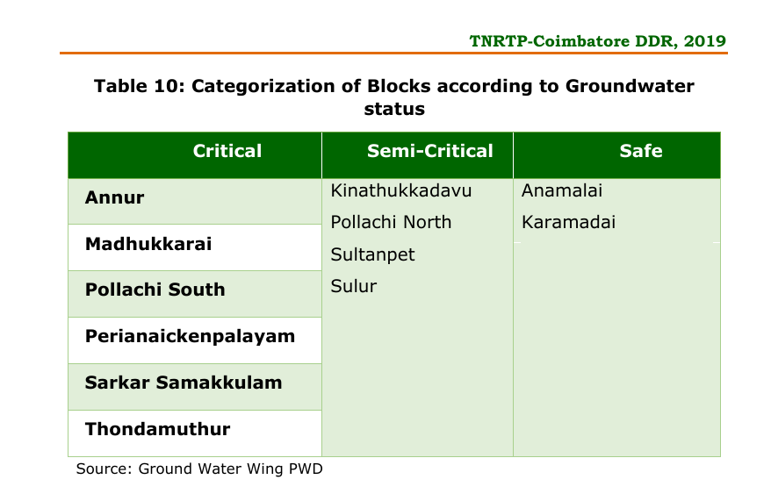According to Groundwater wing PWD six blocks were categorized as critical, four were considered as semi critical and two were safe as far as groundwater status was concerned.
The above mentioned table shows the groundwater status.
SOURCE: District Diagnostic Study Coimbatore district

Understanding from the field visit and enquiry with the farmers
- The farmers need some advice of educated people and need to give solutions.
- Awareness about modern technology is agriculture.
- Need some financial support.
- Modern agricultural
- The effects of using chemical pesticides and fertilizers are not known to them.
- They don’t know about the crop management and how to do proper organic farming.
- Agriculture is the backbone of our nation. As an engineer we have to use technology to give solutions to the problems faced by farmers.
AI-Related Solution and Innovation
To enhance farmer productivity in the Coimbatore region, an AI-driven Smart Agriculture System can be developed. The solution integrates Artificial Intelligence, Machine Learning, and IoT to assist farmers in decision-making, crop health monitoring, irrigation management, and pest detection.

Proposed Innovations
- AI-Powered Crop Health Monitoring
  - Drones or mobile cameras can capture real-time crop images.
  - A trained deep learning model (using CNNs) identifies diseases, nutrient deficiencies, and pest attacks.
  - The system alerts farmers through a mobile app with suggested remedies and organic treatment options.
- Smart Irrigation System using IoT + AI
- Soil moisture sensors and weather data are analyzed by an AI model to optimize irrigation schedules.
- Predictive analytics help manage water usage efficiently, reducing wastage in drought-prone area
- AI-Based Pest and Disease Prediction
- Machine learning models trained on local climatic and pest data predict outbreaks.
- Early alerts help farmers take preventive actions, reducing crop loss.
- Farm Advisory Chatbot (Multilingual)
- A regional-language AI chatbot (in Tamil and English) provides 24/7 guidance about farming practices, market prices, fertilizer use, and government schemes
- Market Intelligence Platform
  - AI models analyze historical market data to predict best times to sell crops and recommend profitable alternatives for next season.

Impact
Area | Expected Impact
Water Usage | Up to 30–40% reduction through optimized irrigation
Crop Productivity | 15–25% increase due to early disease detection and better soil management
Cost Efficiency | Lower input cost through data-driven resource management
Farmer Awareness | Increased understanding of technology and sustainable farming
Environmental Benefits | Reduced chemical fertilizer and pesticide use through precision farming
Scalability Potential
- Regional Expansion: The same model can be adapted to other Tamil Nadu districts with similar climatic conditions.
- Crop Adaptability: The AI models can be retrained for different crops like sugarcane, banana, or paddy.
- Integration with Government Programs: Can link with “Digital Agriculture Mission” or “PM-Kisan” for farmer data integration.
- Commercial Potential: The solution can evolve into a startup offering precision farming as a service (PaaS).
- Sustainability: Continuous data collection will improve model accuracy, making the system more efficient over time.

Conclusion
Low agricultural productivity is a major challenge affecting both farmers and the economy. The causes are interrelated and require a multi-dimensional approach involving technology, policy, and farmer participation. With proper education, financial support, and adoption of modern techniques, the productivity of Indian agriculture can be significantly improved, leading to a more sustainable and prosperous farming community.

Declaration
I hereby declare that this report is based on my original data collection and personal understanding of the chosen problem.
All details such as names, dates, places, and photographs have been genuinely collected by me through field visit, telephonic interaction, or direct research.
I have not used any AI tool or automated platform to generate or rephrase my content.

Name - Monisha K
Department – AIML 1 year
Register no – 7376252AL173

